[COMPUTER VISION AND PATTERN RECOGNITION [C]](https://portal.aiub.edu/Student/Section?q=ZGNZ55p%2FrDvdhSZrbcFYvA%3D%3D)

ASSIGNMENT-1[MID TERM]

Student Name: Shahriar Hossain Rafi

Student ID: 20-42528-1

Submitted to: DR. DEBAJYOTI KARMAKER

1. **Importing the libraries that will be used to build our k-NN model.**

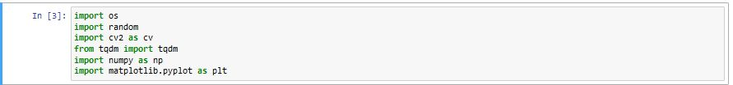

1. **Loading the CIFAR-10 training dataset.**

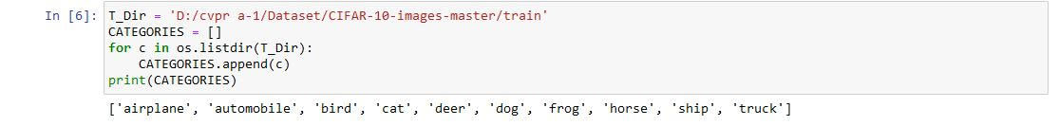

1. **Reading and storing every image from every class by recording them.**

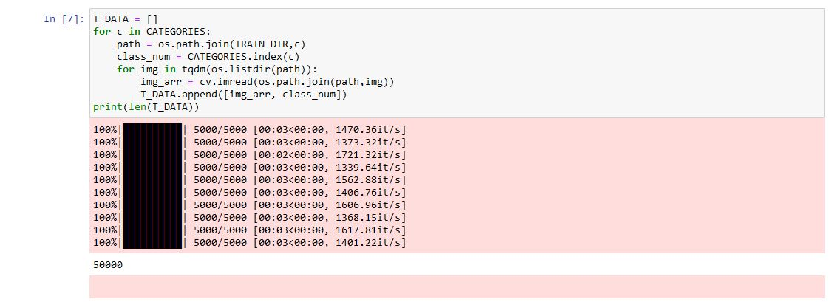

1. **Converting all the images into grayscale.**

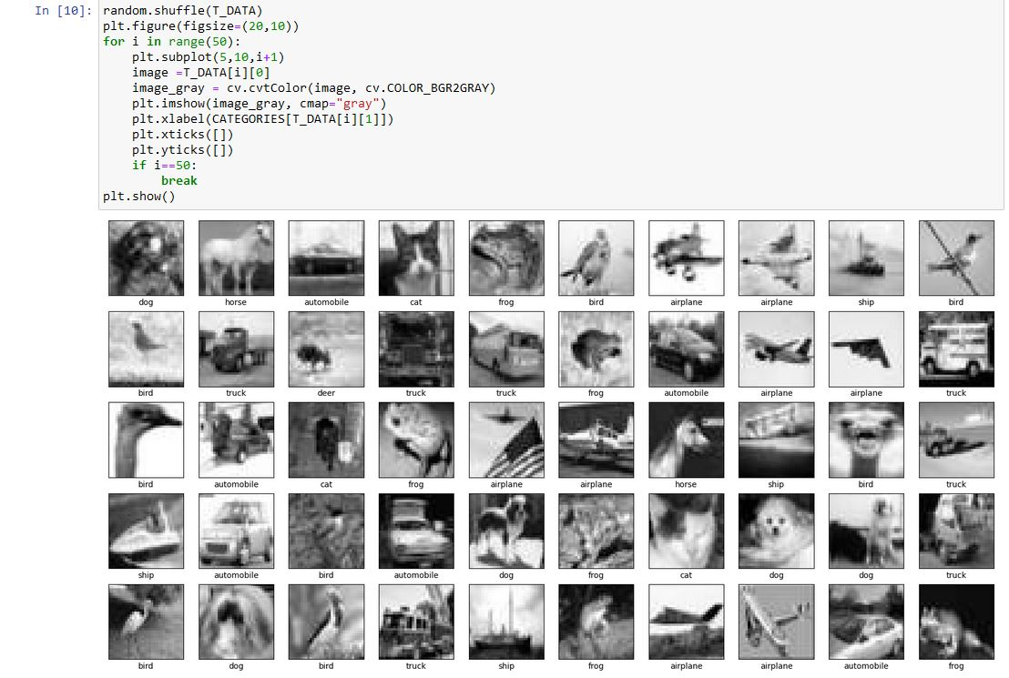

1. **Defining 5 folds of the data and split them as 1000 images per fold.**



1. **Defining L1 and L2 distances**



1. **Training the model and calculating the accuracies for both L1 and L2 distance**

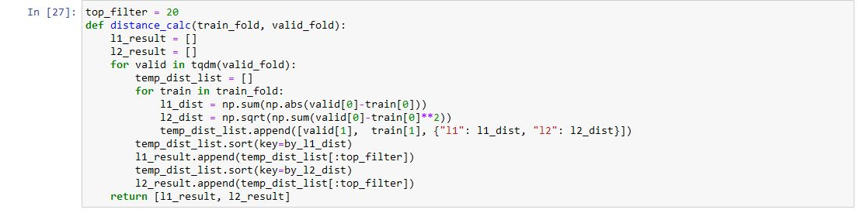

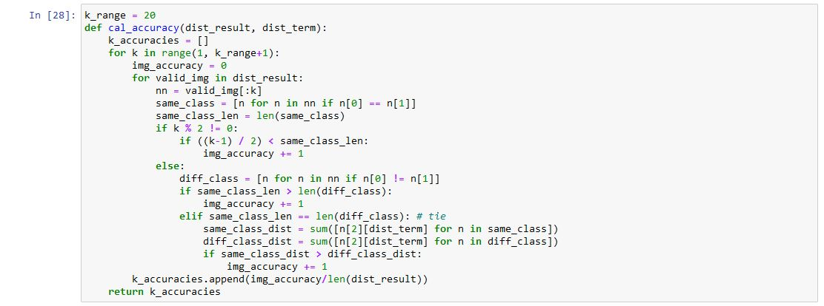

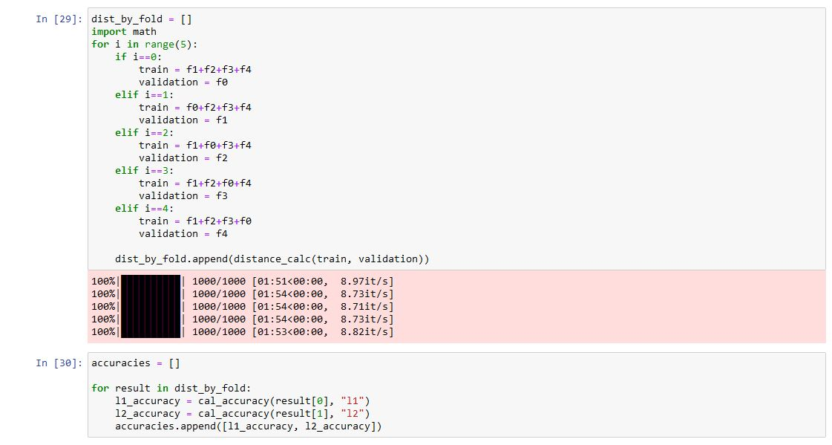

1. **Plotting the results of L1 and L2 distance accuracies.**

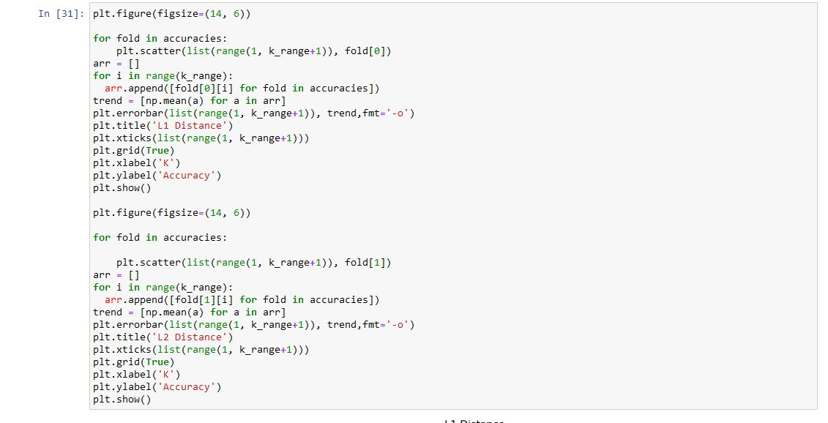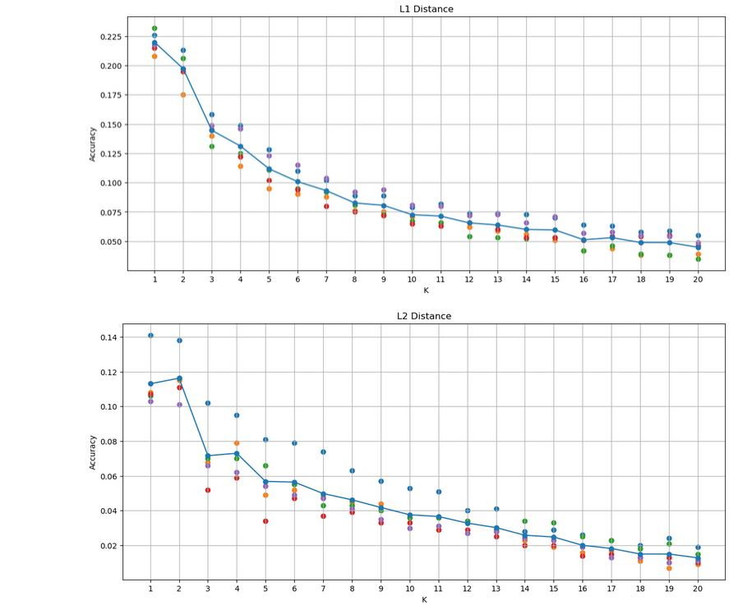

1. **Predicting the top 5 images by L1 and L2 distance. Each Prediction will have the class name that the KNN model predicted and the distance it calculated for that value**

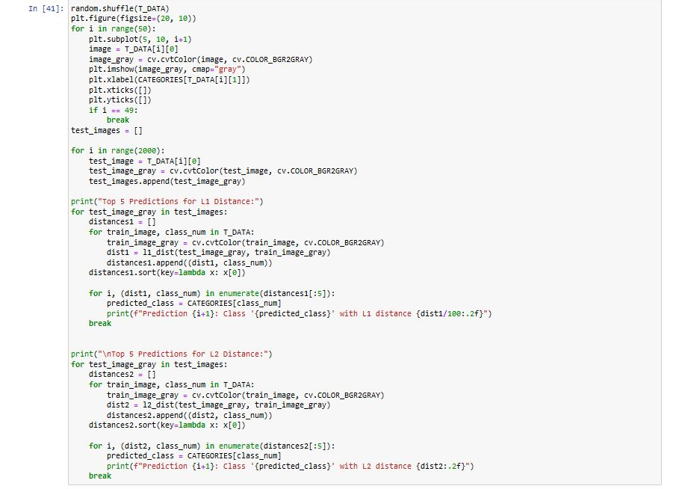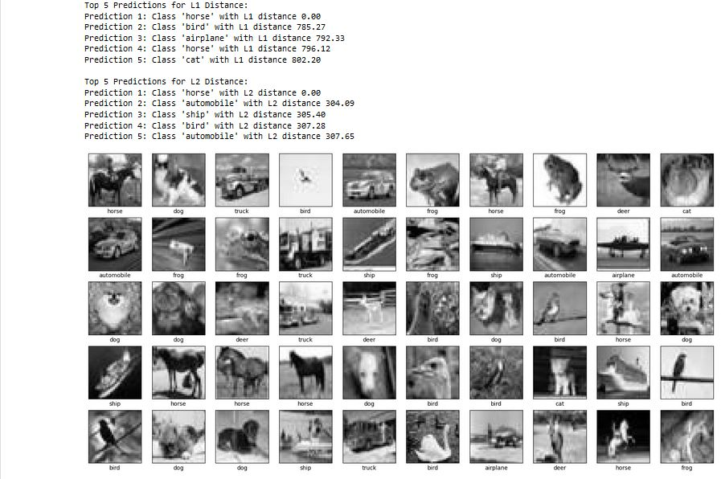

**Discussion:**

The performance of Manhattan (L1) and Euclidean (L2) distances was compared based on the average accuracy values obtained from the 5-fold cross-validation using the CIFAR-10 dataset, which consists of 60,000 32x32x3 color images in 10 different classes. Aim was to determine which distance calculation technique is most appropriate for the given gray-scale dataset. According to the analysis, the L1 distance exceeded the L2 distance in terms of accuracy. The Manhattan (L1) and Euclidean (L2) distance comparisons illustrated the significance of taking dataset characteristics and feature nature into account when choosing a distance calculations approach.